VnV
Mini Project /PLP

Loan Application Processing System
(LAPS)

Document Control

Reference No:
Security Classification: | iGATE Internal
Issue Date:
Author(s): | Name |  | Title
Author(s): | Vaishali Kulkarni |  | Training Specialist
Reviewer(s): | Name |  | Title
Reviewer(s): | iLEARN Seniors Team |  | Sr. Faculty, Sr. Managers
Issuer(s): | Name |  | Title
Issuer(s): | Dinesh Anantwar |  | Sr. Manager
Issuer Signature(s):
Distribution: | Name |  | Title
Distribution: | iLEARN Team, PPPs |  | All Designations in iLEARN
Document History: | Date | Revision | Change
Document History: | Nov 30, 10 | 0.01D | Initial draft
Document History: |  | 0.02D | Review comments incorporated

Table of Contents
1 Introduction 4
1.1 Setup Checklist for Mini Project 4
1.2 Instructions 4
2 Problem Statement 5
2.1 Objective 5
2.2 Abstract of the project 5
2.3 Functional components of the project 5
2.4 Guidelines on the functionality to be tested: 7
2.5 Evaluation and assessment parameters: 12
2.5.1. Guidelines on the functionality 12
2.5.2. Evaluation Policy 12

Introduction

This document outlines a mini project for the V&V LOT. The project is to test an online Loan Application Processing System (LAPS). ”. This document contains the work flow of the system and gives guidelines on how to test the functionality gradually in each of the course modules of the V&V LOT.

Setup Checklist for Mini Project
Minimum System Requirements
- Intel Pentium 90 or higher (P166 recommended)
- Microsoft Windows 95, 98, or NT 4.0, 2k, XP.
- Memory: 32MB of RAM (64MB or more recommended)
- Internet Explorer 6.0 or higher
- MicroSoft Word and Excel 2003 or higher

Instructions
- The test cases should follow the test case standards.
- Create a directory by your name in drive D. In this directory, create a subdirectory MiniProject<Groupcode>. Store your Project here.Every document related to your mini project should be available in the same directory.
- You can refer to your course material.
- You have to follow the flow while doing the mini project, like Requirement Itemization -> Use cases -> Use case level test cases -> Form level test cases -> Filed level Test cases.

Problem Statement

Objective
Test an online Loan Application Processing System (LAPS), for a home finance provider.

Abstract of the project
This project is aimed at testing an online Loan Application Processing System (LAPS), for a home finance provider, which is used by customers to apply for loan and by the loan approval department (lad) for processing loan. This is a web based application that can be accessed throughout the web. This system can be used by the customers to search a suitable loan program offered by the home finance provider without any login and fill up the loan application form, administration staff can add/update/delete any loan program that the home finance provider offers/updates/cancels. Members of loan approval department (lad) have the responsibility to verify information provided by the customer and take a decision on the approval of loan in consultation with concerned approvers. There are features like email notifications, report generators etc in this system.

Test the Application for the above requirement using the following Project link:

http://192.168.107.179:8080/JspLoanApplication

Use following user credentials to access above given project link.

Username | Password | Role
user1 | pwd1 | Admin
user2 | pwd2 | lad

Functional components of the project
Following is a list of functionalities of the system. Wherever, the description of functionality is not adequate; you can make appropriate assumptions and proceed.

There are three categories of people who would access the system viz. customers (loan applicants), members of loan approval department (lad) and administrators. Each one of them would have some exclusive privileges (for e.g. Customers can apply for a program by filling up the online form without any login process, members of loan approval department (lad) alone will be able to view loan applications, approve or reject the application for a specific loan program. Only the administrator has the right to keep track of the home finance provider’s loan program details.)

- Customers should be able to

  - View all loan programs offered by the home finance provider
  - Apply online for a loan program offered by the home finance provider, by filling up the application form that auto generates the application ID
  - View the application status of application, based on the application ID

- The member of loan approval department (lad) should be able to :

  - Login into the system using his/her credentials.
  - View all loan programs offered by the home finance provider
  - View loan applications for a specific loan program.
  - Accept/Reject an application on the basis of the details of the loan applicant. If loan application is acceptable, loan application status is changed to ‘Accepted’, the scheduled date for an interview (of the loan applicant for verification of applicant’s documents, before approving the applicant’s loan under the mentioned loan program) is filled into the application form.
  - After the interview, the status of the loan application is changed to Approved/Rejected

- The administrators should be able to

  - login to the system using his/her credentials
  - Update and manage (add or delete) information of the loan programs offer by the home finance provider
  - Generate various reports like:
    - View List of loan applications approved/accepted (waiting for interview)/rejected for a loan program.
    - View all loan programs offered by the home finance provider

- Automatic reminder email should be sent to the loan applicant on change in loan application status, immediately after the status is updated. For example, when the loan application status changes from ‘Applied’ (which is default status), to ‘Accepted’, the date of interview is emailed with mention of the documents the applicant will have to bring for verification. This date will be entered by members of loan approval department (lad), when they change the status of loan application.

Transition of Status: Applied ->Accepted/Rejected->Approved/Rejected

Guidelines on the functionality to be tested:

- Tables
  - Following database tables were used in this application to store the information:
    - LoanApplicantion: This will contain the list of valid loan applications (Loan Applicants fill in the application form)
    - CustomerDetails : This will contain details of the customers (Loan Applicants), extracted from the loan application form that is filled by the customers (loan applicants) to apply for loan offered by the home finance provider
    - LoanProgramsOffered: This will contain details of loan programs offered by the home finance provider
    - ApprovedLoans : This will contain details of approved loans
    - Users : This will contain all the valid logins and passwords, there is no screen to enter values in this table, assume that this table is present with valid data, that will be used by this application
  - The structure of the above listed tables is as follows:
    - LoanApplication : Application_id (auto generated serial no.),application_date(date),Loan_program(varchar(10)),AmountofLoan(number),AddressofProperty(varchar(30)),AnnualFamilyIncome(number),DocumentProofsAvailable(varchar(50)),GuaranteeCover (varchar(20)),MarketValueofGuaranteeCover(number), Status(varchar(10)), DateOfInterview(date)
Note :
- Possible values of status are ‘applied’ by default, ‘accepted’ ,’rejected’ and ’approved’
- Application date is systems date
- Program ID of the loan program that is selected by the applicant
- Address of Property on which loan is required
- What document proofs can be produced by the applicant
- Specify the details, in case applicant can provide guarantee cover and its market value
- In case the application is accepted, the date on which the applicant is expected to visit the home finances provider’s office. The applicant is expected to produce the documents (as proof of genuineness) of the information provided by the applicant.

    - CustomerDetails:Application_ID(FK),Applicant_name(varchar(20)),date_of_birth (date), marital_status(varchar(10)), phone_number(number), mobile_number(number), CountofDependents(number), email_ id(varchar(20)),
Note :
- Personal details of the customer (applicant) are extracted from the loan application form

    - LoanProgramsOffered: ProgramName (varchar(5)), description (varchar(20)), type(varchar(00)), durationinyears(number), minloanamount(number),maxloanamount(number),rateofinterest(number), proofs_required(varchar(20))
Note :
- Loan types are Purchase,Construction,Extension,Renovation

    - ApprovedLoans: Application_ID(FK), Customer_name(varchar(20),amountofloangranted(number),monthlyinstallment(number),yearstimeperiod(number), downpayment(number),rateofinterest(number), totalamountpayable(number)
Note :
- Customer_name is same as applicant name

    - Users : login_id(varchar(5), password(varchar(10)), role(varchar(5))
Note :
- Possible values of role are ‘admin’,’lad’

The functionality and components to be test in each of the module is as follows:

  - Requirement for the application:
    - View Loan Programs screen: This screen provides the customers (loan applicant) with information on the loan programs offered by the home finance provider. This screen has a link to ‘Apply for Loan ’ only if viewed by customers. Same screen is available to the administrators as well as members of loan approval department (lad), for them the ‘Apply for Loan ’ link does not appear.
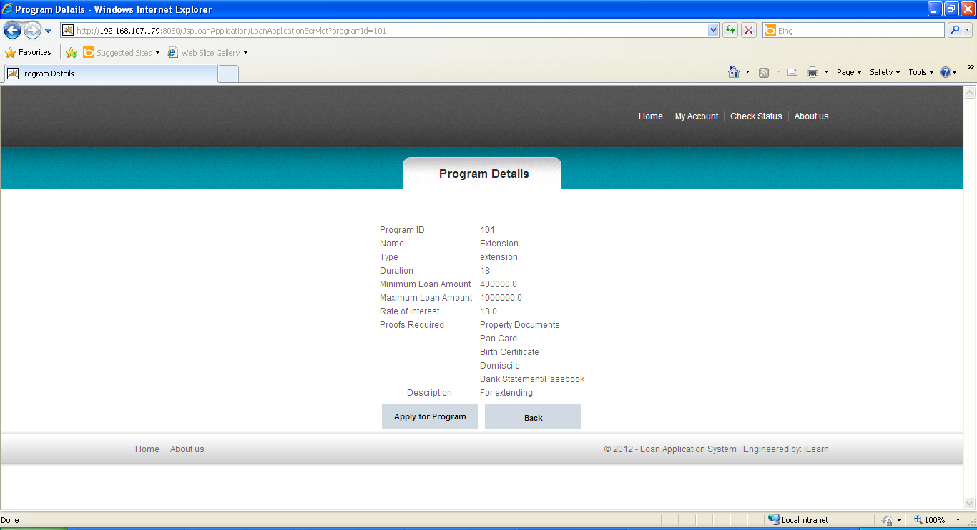
    - Apply for Loan: Allows customers (loan applicant) to fill in and submit loan application form for a loan program. These details are stored in the LoanApplications table, an applicant ID is auto generated at DB level. The loan application form also includes personal details of the customer that will be stored in the CustomerDetails table.
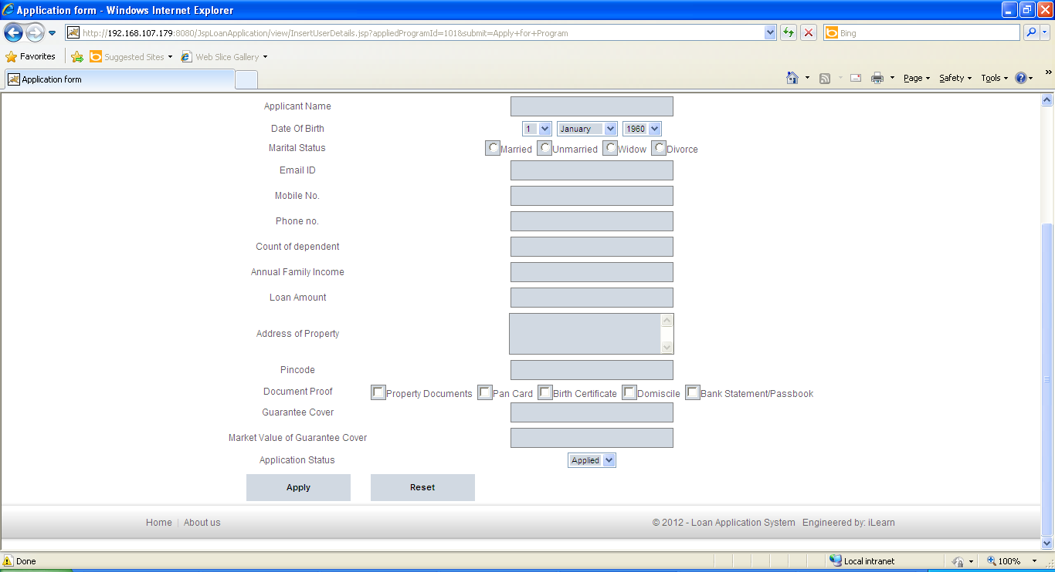
    - View Loan Application Status: Allows customers (loan applicant) to view the status of their loan application by entering the Applicantion_id
Note : No login is required for the screens available to the customers(loan applicant).

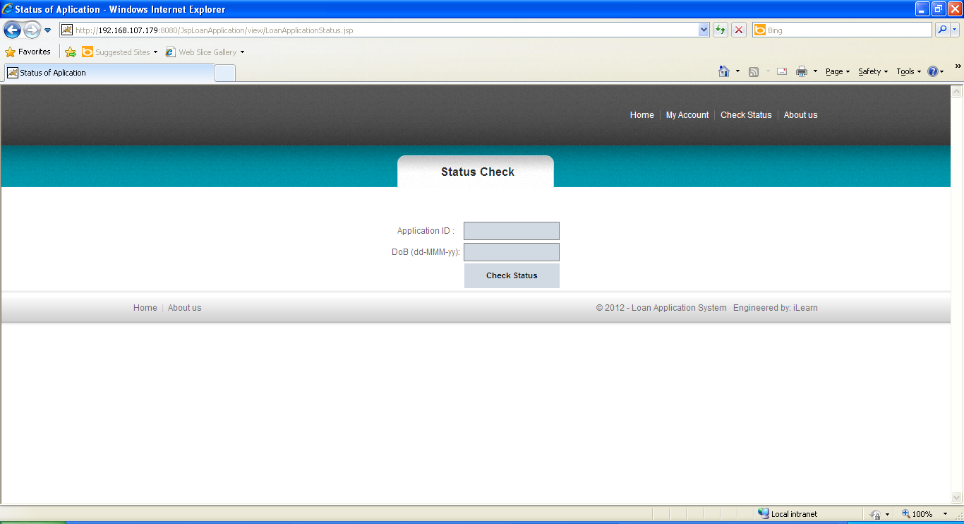
    - Maintain Information on Loan Programs Offered : This functionality should be available only for authorized administrators. Administrations maintain valid information about loan programs offered by the home finance provider (add new / delete existing) such that it does not affect the integrity of the data. Update details of loan programs offered only if it does not affect the existing applicants for that loan program and only relevant fields are updatable.
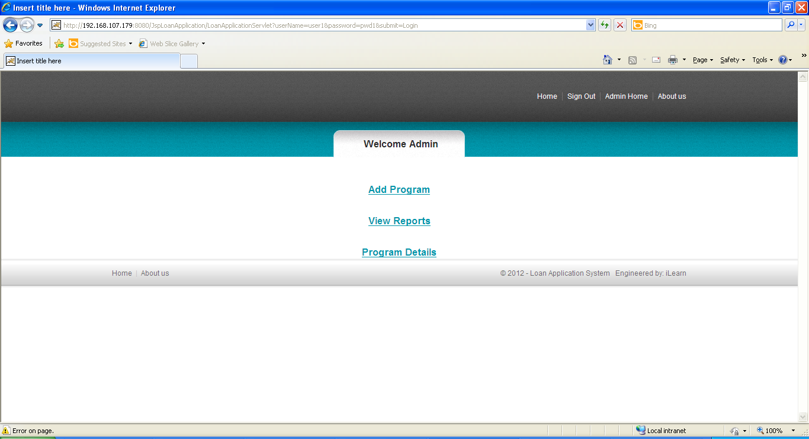
    - Loan Approval Screen: This screen should only be available to authorized members of loan approval department (lad). He/She must be able to view the loan applications for a specific loan program, Accept/Reject the loan application and update the loan application status accordingly. If the loan application is ‘accepted’ for the program, an interview date should be entered, (during the interview, document proofs and the customer’s information will be verified by the loan approver). If loan applicant’s interview is already conducted, the loan application status should be changed to either Approved or Rejected. Any change in the status of an application should result in an email being sent to the customer (loan applicant) notifying him/her the details of change in status.
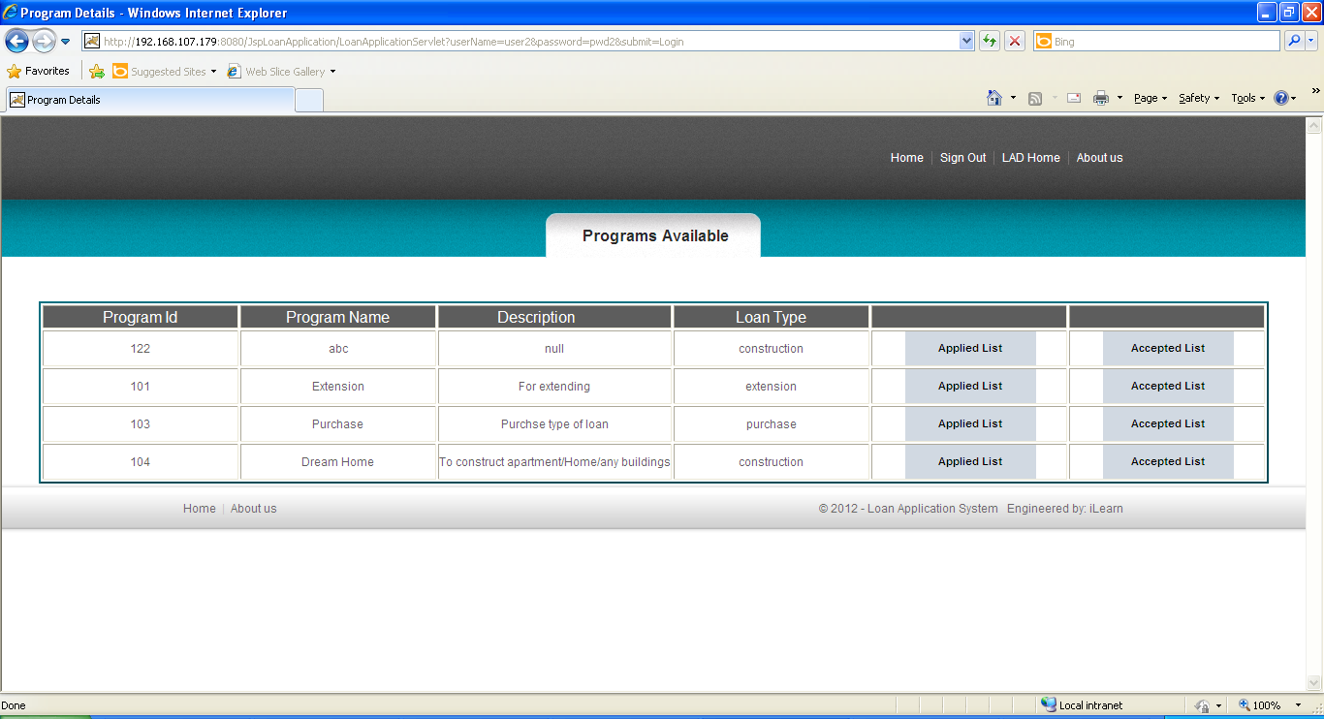
    - View list of applications Accepted/Rejected/Confirmed for a particular Loan Program: This should display details of loan applicants Accepted/Rejected/Approved for a particular loan program. This functionality should be available only for authorized administrators.
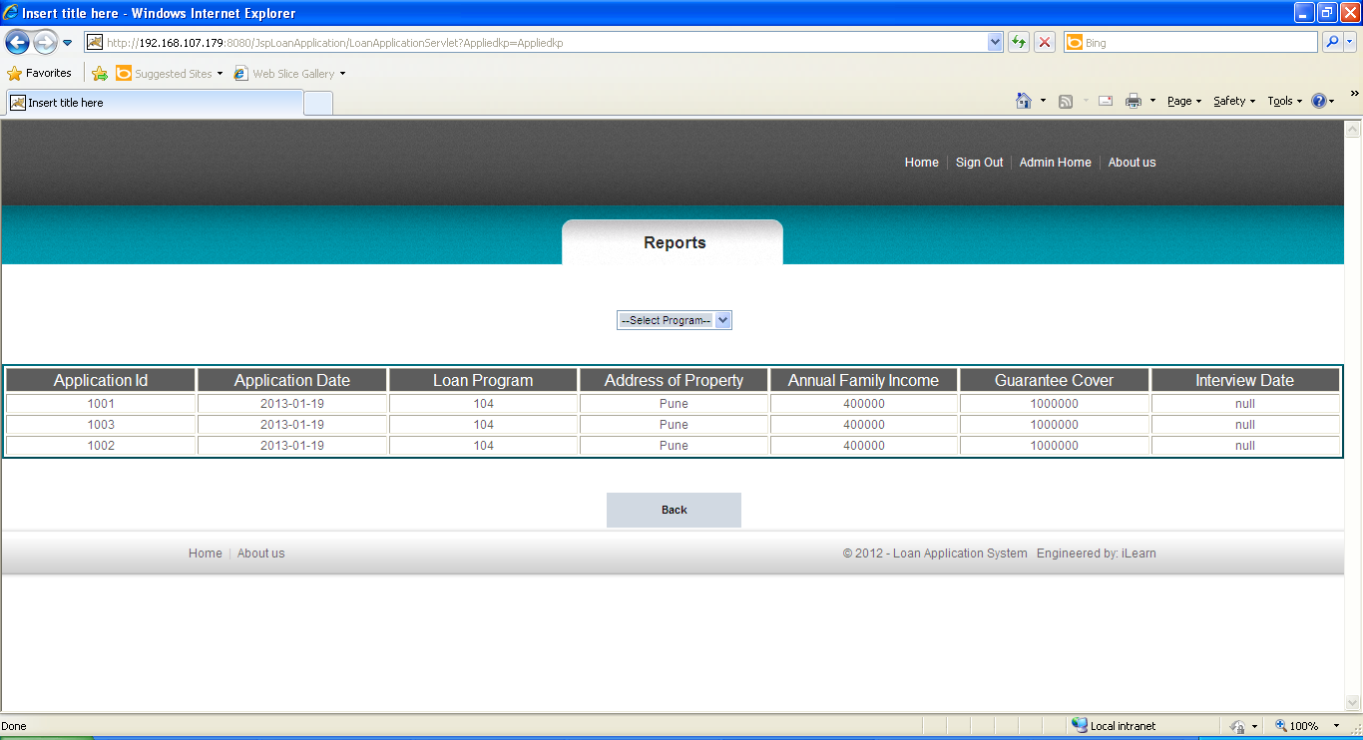
    - View Loan Applications for a Loan Program : This should only be available to authorized members of loan approval department (lad). He/She must be able to view all the applicant data based on loan program
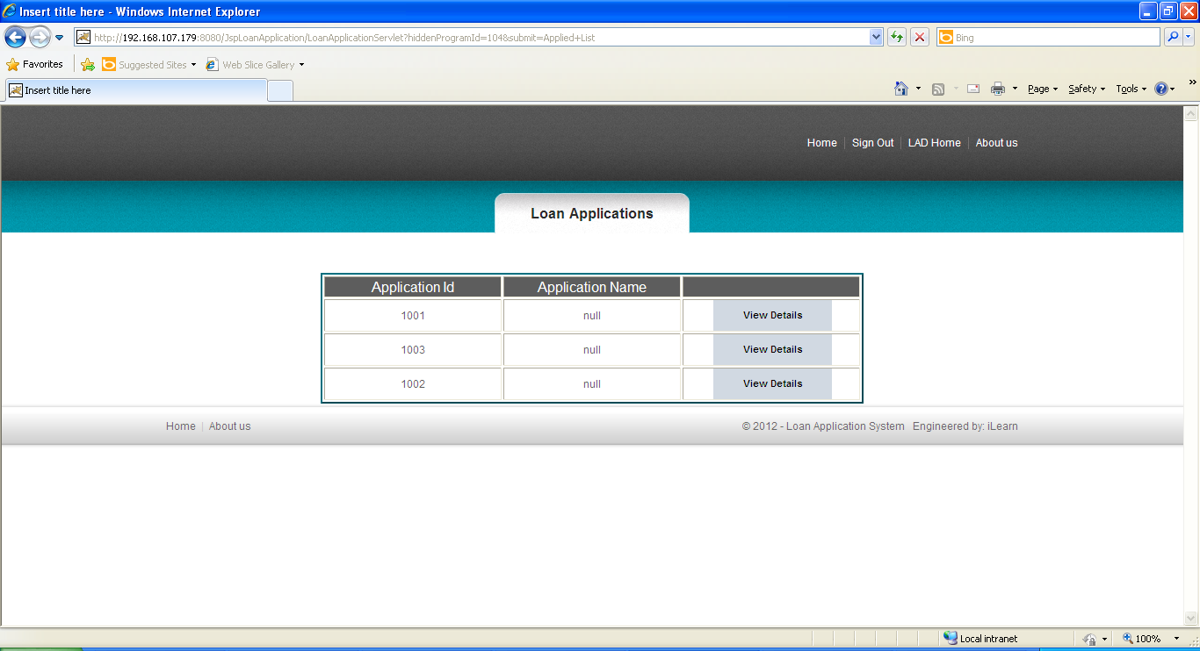

  - Test all other screens and links that appear in the application for admin, Lad and customer.

  - Test the following functionality:
    - Login verification: This component will authenticate the user. Verify if the user who is trying to access the system is a valid user. This verification is as against the valid users listed in the users table, which has valid logins for administrators and members of loan approval department (lad).There is no login required for a customer (loan applicant).

    - Retrieve Loan Programs Offered: This component provides information on all loan programs offered by the home finance provider. Available to all users.
    - Apply for Loan: This component should allow a customer (loan applicant) to submit his/her loan application for a loan program. An Applicantion_id is auto generated at DB level and shown to the loan applicant.
    - Retrieve Loan Application Status: A customer (loan applicant) should be able to view the status of his/her loan application by entering the Applicantion_id

    - Maintain Loan Programs Offered Information: This is a typical CRUD (Create/Read/Update/Delete) operation. This functionality should be available only for authorized administrators. Administrations maintain information about the Loan Programs Offered (add/update/delete) by the home finance provider. Only valid operations should be performed on the data, so that the data integrity is maintained, and it des not lead this s/w application to an ambiguous state. For Ex. A loan program offered cannot be deleted /updated if there are loan applicants in the phase of approval for it.

    - Retrieve Applications for Loan Program : This should only be available to authorized members of loan approval department (lad). This component should retrieve all loan applicant data based on loan program

    - Approve Loans : This component allows for update status of a loan application and enter the date of interview only upon ‘Accepting’ an application. This should only be available to authorized members of loan approval department (lad). [He/She must be able to view the loan applicants for a specific loan program and Accept/Reject the application and update the application status accordingly.] Status can be changed to ‘approved’ only after, the previous status was ‘accepted’ and the date of interview is present, dated previous to or same as today’s date. If the application is accepted for the loan program, an interview date should be entered. If the applicant’s interview is conducted, the status should be changed to either Approved or Rejected. Any change in the status of an application should result in an email being sent to the applicant notifying him/her the details of change in status.

    - Mail notification: This component will generate an email with a message of change in the application status and send it to the loan applicant. There is no direct access to this component for any login, it is only meant to be used by ‘Approve Loans’ component.

    - View list of applications Accepted/Rejected/Approved for a particular Loan Program : Available to only administrators this component retrieves details of loan applications Accepted/Rejected/Approved for a particular loan program

Evaluation and assessment parameters:
The participants need to do Requirement Itemization and to develop Use case, Scenario matrix and test cases for the Loan Application Processing System using TBA template and defect report while test execution.

Guidelines on the functionality
Form a group of 5 people. One person will be group leader will divide the work among the group members.

Evaluation Policy
Sr. No | Marks | Project Execution
 | 100 | Evaluation shall be done after the DFDR course is over. Participants shall submit the sheet along with V&V DFDR assignments.

Following points will be considered for giving marks:

Sr. No | Points to be considered | Marks
 | Writing test cases in appropriate sheets. | 30
 | Defect report creation | 20
 | Proper and concise explanation of test cases and Input data | 30
 | Format of the sheet | 10
 | Complete solution | 10

